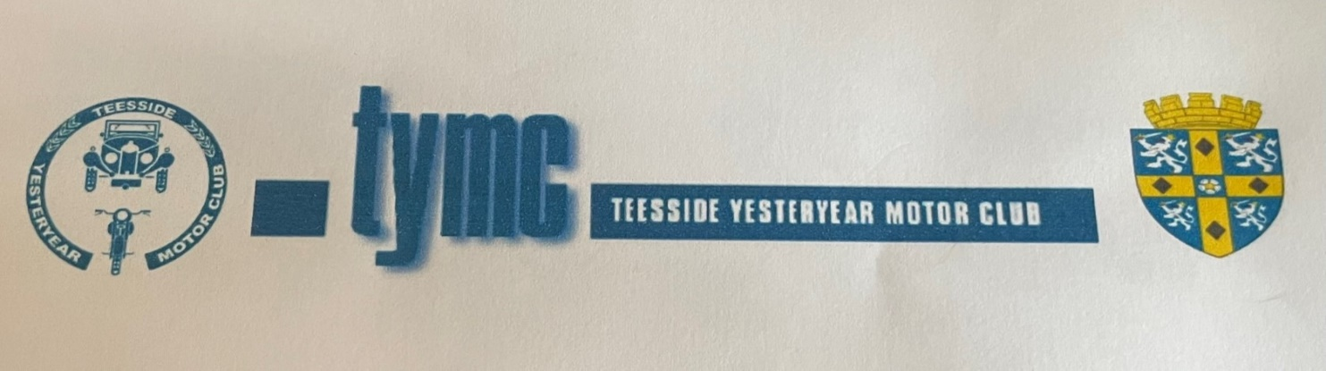

Presents
The 28th Durham Dales Classic Motorcycle Run

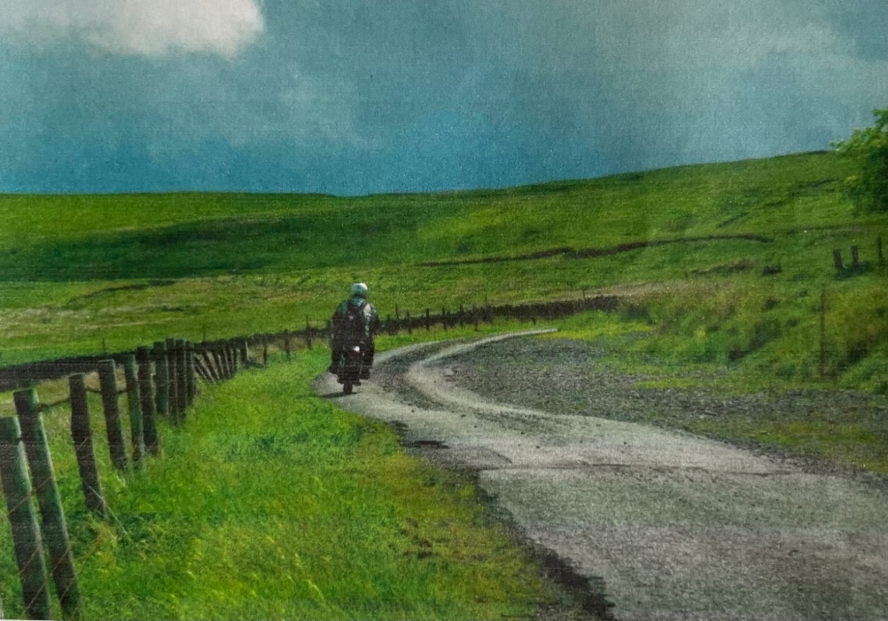

Sunday 9th June 2024

Organised by Teesside Yesteryear Motor Club this established event offers the chance to take in some of the most beautiful scenery the region has to offer. Starting and finishing from the Crown Inn, Manfield near Darlington, the run of around 100 miles covers some of the most picturesque roads in the Durham Dales, Weardale and the North Pennines, with a lunch stop at Allenheads. Any age or make of machine is welcome but the emphasis is on those from the classic period and numbers are limited so pre-booking is recommended. Closing date for entries is the 25th May 2024.

Further details and entry forms visit www.tymc.org.uk, or jeantom30@aol.com

